|  |  |  |  |  |  |  |
| --- | --- | --- | --- | --- | --- | --- |
| |  |  |  |  | | --- | --- | --- | --- | |  | | **MINISTRY OF EDUCATION AND TRAINING** | | | **FPT UNIVERSITY** | | |
| Capstone Project Document |
| Online Medical Consultant System |
| |  |  |  |  |  |  |  |  |  |  |  | | --- | --- | --- | --- | --- | --- | --- | --- | --- | --- | --- | | |  |  | | --- | --- | | **Group 02 – Report 1** | | | **Group member** | Trần Nguyên Tiến Sứ - Team Leader - SE60781  Trần Cao Danh - Team Member - SE60705 | | **Supervisor** | Mr. Nguyễn Huy Hùng | | **Ext. Supervisor** | N/A | | **Capstone Project code** | OMCS | | |
| * Ho Chi Minh City, 11 May / 2014 – |

Table of Contents

Part B. Introduction 3

1. Project Information 3

2. Introduction 3

Part C. Project Management Plan 4

1. Problem Definition 4

1.1. Name of this Capstone Project 4

1.2. Problem Abstract 4

1.3. Project Overview 4

2. Project organization 6

2.1. System Process Model 6

2.2. Roles and Responsibilities 8

2.3. Tools and Techniques 8

3. Project management plan 9

3.1. Product Backlog 9

3.2. Sprint Backlog 9

3.3. All Meeting Minutes 9

4. Convention Rules 9

# Introduction

## Project Information

* Project name: **Online Medical Consultant System**
* Project Code: **OMCS**
* Product Type: **Web Application**
* Start Date: **May 11th, 2014**
* End Date: **August, 20th, 2014**

## Introduction

With the emergence of the Internet, many systems have been built to reduce the gap between patients and doctors. They provide the convenient way by let patient communicate face-to-face with health care provider via social media. That is successful story from many developed countries that we try to apply for Vietnam using different approaches.

Nowadays, Vietnam hospitals usually are overwhelmed[1] with patients. A lot of plans have been proposed to handle that situation[2]. Besides that, taking a medical treatment at hospitals not always a good choice due to the traveling cost, wasting time and unsafeness[3].

Based on observation, we see that there are many cases that patients don’t need to go to the hospital quite often because those can easily conduct via internet. So we want to improve the processes of medical treatment.

Reference:

[1] http://nld.com.vn/suc-khoe/loay-hoay-chuyen-giam-tai-benh-vien-20120315104111496.htm

[2] http://www.vietnamplus.vn/no-luc-giam-qua-tai-cac-benh-vien-tai-tp-ho-chi-minh/245738.vnp

[3] http://www.nhandan.com.vn/suckhoe/tieu-diem/item/22586202-bat-an-nhu-vao%E2%80%A6-benh-vien.html

[4] http://www.jmir.org/2013/10/e220/

# Project Management Plan

## Problem Definition

### Name of this Capstone Project

The official and formal project name is “Online Medical Consultant System”. Its abbreviation is OMCS.

### Problem Abstract

This system aims to provide the convenient way for doctor and patient to exchange information (chatting, sharing webcam, attachment).

In order to conduct a high quality consulting based on reliable information. This system helps hospitals to build medical profile template.

With many medical profiles linked to one patient, it’s more easier to extract some common information like immunization, allergy.

### Project Overview

#### The Current System

In Vietnam, there are some websites provide medical consultant services:

* **Alobacsi** *“Vì sức khỏe người Việt”*

<http://alobacsi.vn/kham-benh-online.htm>

Users can search questions in knowledge base (nearly 100.000 questions with answers). Make question by submit the form

* **Tuvansuckhoe24h** *“Chia sẽ cùng chuyên gia”*

<http://www.tuvansuckhoe24h.com.vn/>

Support chatting using yahoo. Ask question for consultants

* **Bacsytructuyen**

<http://bacsytructuyen.com/>

This website collect articles, tips related to medical from many resources. Users can access those information. Besides that, patients can submit question by filling the form

All above systems have many disadvantages:

* Lack of interaction between patients and doctors
* Hardly can provide high quality consulting service due to missing reliable resources (medical profile, allergy, immunization,…)
* Patient cannot able to manage their own profile information, medical heath record

#### The Proposed System

The main system will be a website. It’s intended for used in one hospital or clinic.

The system will provide the following main features:

* *Hospital admin:*
* Define a template for medical profile with high customization, reusable patient information and built-in components.
* Update hospital information.
* Manage doctors, patients, specialty fields, film types, allergy types.
* Manage all created medical profiles.
* Manage comments from patient.
* *Doctors:*
* Manage patient information.
* Use predefined templates to create medical profile for patient.
* View conversation history, chat with patient.
* Request patient to show their webcam.
* View medical profile template.
* *Patients:*
* Manage some basic information, health medical record.
* View their medical profile.
* Request doctor to get consulted, share webcam, upload attachment.

#### Boundaries of the System

* The system is intended for using in one hospital (we named it as FPT Hospital)
* The language of the system is Vietnamese.
* The complete product includes:
* The website, for admin, doctor, patient to interactive with system.
* All the documents, reports during the time develop the system.
* This system currently not included for these features:
* Exporting medical profile.
* Managing medicine.
* Managing process of a hospital.
* This system not intend to replace the current medical treatment processes in hospital. It just provide the convenient and reliable ways to conduct medical consultant online, especially in re-examination.

#### Development Environment

#### Hardware requirements

**For server**

|  |  |  |
| --- | --- | --- |
| Windows | Minimum Requirements | Recommended |
| Internet Connection | 4Mbps | 8 Mbps |
| Operating System | Window Server 2008 | Window Server 2012 |
| Computer Processor | Intel® Core 2 Duo | Intel® Core(TM) i5 CPU , M 460 @ 2.53GHz |
| Computer Memory | 1GB RAM | 3GB or more |

Table : Hardware Requirement for Server

**For Web User**

|  |  |  |
| --- | --- | --- |
| Web | Minimum Requirements | Recommended |
| Internet Connection | 2Mbps | 4Mbps |
| Web Browser | Chrome 22 | Chrome 36 |

Table 2: Hardware Requirement for Web User

#### Software requirements

* OS: Microsoft Windows 7.
* Skype: used for communication and meeting
* Google Code & TortoiseSVN: used for source control.
* Website Server: IIS 7 Express
* IDE: Visual Studio 2012
* DBMS: SQL Server 2008 R2
* StarUML 5.0

## Project organization

### System Process Model

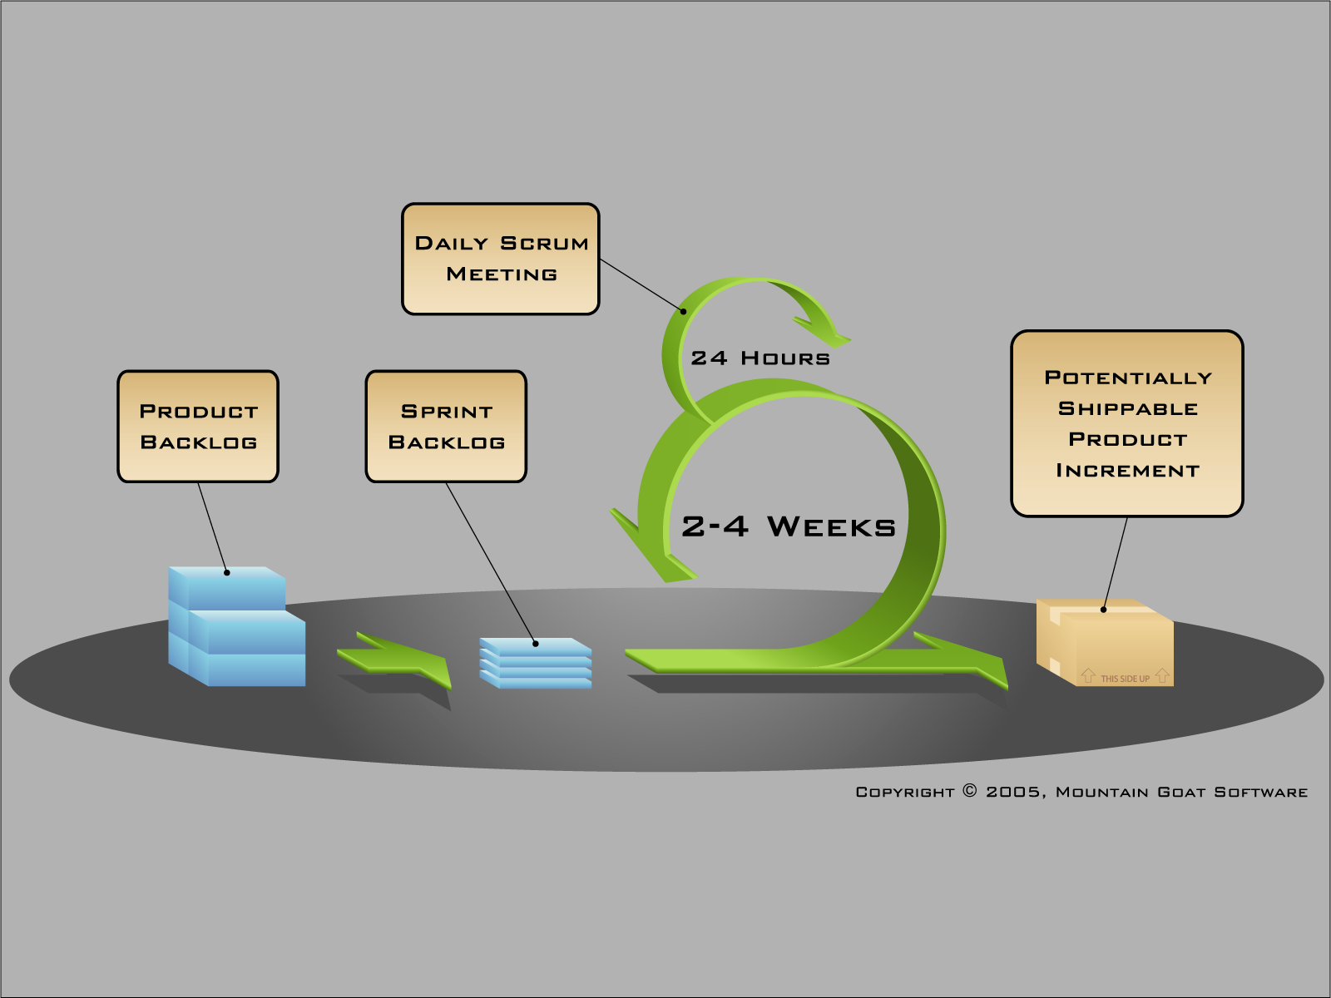

Figure 1 Scrum framework

We decided to apply SCRUM methodology in our project with many customizations:

* **Roles**

Teacher plays as a Product Owner and Scrum Master

Students play as Development Team

* **Event**

*Sprint*: each sprint is timeboxed for one week. Start and end at the same date

*Meeting*:

* *Planning 1*: choose stories from product backlog and put them into sprint backlog
* *Planning 2*: not conduct due to lack of time and resources
* *Daily meeting*: conduct every evening by using Skype
* *Review meeting*: conduct at the end of sprint where PO review the work that was completed
* *Retrospective meeting*: rarely hold. To take a look back on the previous sprints and discuss to made agreement for improvement
* **Artifacts**

*Product backlog*: list of requirements that are created and managed by PO.

*Sprint backlog*: list of works for the Development Team must address during the sprint.

*Burndown chart*: not conduct

*Impediment*: list of difficulties that the team meet during handle tasks.

* Reference Appendix: Impediment Backlog.

### Roles and Responsibilities

|  |  |  |
| --- | --- | --- |
| Full name | Role in Group | Responsibilities |
| Nguyễn Huy Hùng | Scrum Master, Product Owner | * Ensuring the team deliver value to the business * Manage product backlog, prioritizes userstory * Facility the team |
| Trần Nguyên Tiến Sứ | Team member | * Tracking & managing progress. * Designing database. * Analyzing requirements. * Planning & scheduling. * Coding. * Testing. * Writing documents & reports |
| Trần Cao Danh | Team member | * Analyzing requirements. * Designing database. * Coding. * Testing. * Writing documents. |

Table Roles and Responsibilities

### Tools and Techniques

#### Tools:

* IDE: Microsoft Visual Studio 2012.
* DBMS: Microsoft SQL server 2008 R2 Express: Used as the database of the system.
* SVN: TortoiseSVN.
* Task management: Trello (<https://trello.com/>)
* Web browsers: Google Chrome, Firefox.
* Web Server: Microsoft IIS 7.0

#### Technologies:

* Web framework: ASP.NET MVC 4
* Entity Framework Model First
* Front-end: Backbone.js, Underscore.js, RequireJS, HTML 5, CSS 3, AJAX, Bootstrap

## Project management plan

### Product Backlog

|  |  |  |  |  |  |  |
| --- | --- | --- | --- | --- | --- | --- |
| **No.** | **Category** | **Userstory** | **Description** | **Acceptance criteria** | **Delivery date** | **Sprint** |
| 1 | Document | Report 1 | As a team member, I want to have the introduction about the project so that I can understand the initial idea. | The report should follow the template from FPT University Good layout, cover all items | 20 May, 2014 | 1 |
| 2 |  | Report 2 | As a team member, I want to have the Project Management Plan so that I can work well on the project | The report should follow the template from FPT University Good layout, cover all items | 05 June, 2014 | 2, 3 |
| 3 |  | Report 3 | As a team member, I want to have the System Requirements Specifications | The report should follow the template from FPT University Good layout, cover all items All features are listed out and analysed carefully | 12 June, 2014 | 3, 4 |
| 4 |  | Report 4 | As a team member, I want to have the System Design Specifications so that I can have a good design to follow | The report should follow the template from FPT University Good layout, cover all items | 09 July, 2014 | 4, 5, 6, 7, 8 |
| 5 |  | Report 5 | As a team member, I want to have System Implementation & Test document so that I can have full-featured and well-tested release | The report should follow the template from FPT University Good layout, cover all items | 09 July, 2014 | 9, 10 |
| 6 |  | Report 6 |  |  | 05 June, 2014 | 2, 3 |
| 7 |  | Team document | As a team member, I want to have some document  (product backlog, sprint backlog, team wiki) created. So I can work well on OMCS | Product backlog with detail description, acceptance criteria, and delivery date Sprint backlog with breaked tasks with assignee |  | 1 |
| 8 | Feature | [User] Login | As a user, I want to login to the system | Login using email After login, redirect user based on their role |  | 1 |
| 9 |  | [User] Login with remember me | As a user, I want to login automatically |  |  |  |
| 10 |  | [User] Logout | As a user, I want to logout |  |  |  |
| 11 |  | [User] Register | As a guest, I want to register new account | Only required some basic information Send email to confirm email address Use capcha to enhanced security |  | 1 |
| 12 |  | [User] Forget password | As a user, I want to get new password by email when I forgot it, so that I can continue to use OMCS | Send email with gerenated new password |  | 1 |
| 13 |  | [User] Edit profile information | As a user, I want to update some information (firstname, address…) | Validate required fields, number |  | 1 |
| 14 |  | [Patient] View medical profile | As a patient, I want to view my medical profile, so that I can have overview about my dieases | List all medical profiles created for logged in patient Not allow patient to modify medical profile |  |  |
| 15 |  | [Patient] View linked medical profile information | As a patient, I want to extract some information (immunization, allegy) so that I can quickly have overview about them | Only show medical profile that use built-in modules (immunization, allergy) Link to medical profile that have extracted information |  |  |
| 16 |  | [Patient] Update patient information | As a patient, I want to update some information about my profile, basic health record | For user experience, use in-place editor to edit information |  |  |
| 17 |  | [Patient] Chat | As the user, I want to chat with doctor realtime So I can send message and doctor receive immediately | The behavior could be: The system list out all doctors with their status Patient can select doctor to chat with Patient can see old chat content |  |  |
| 18 |  | [Patient] Show webcam | As a patient, I want to share my webcam so the information's exchange is more easier | Doctor can see the stream that patient share Doctor can see the stream in full-screen |  |  |
| 19 |  | [Patient] Upload attachment | As a patient, I want to attach some files, images and send to doctor | If attach files are images, display on the chat content, otherwise, let doctor download it |  |  |
| 20 |  | [Patient] View consult history | As a patient, I want to see previous chat content with doctor, so that I haven't to remember everything | List all chat content with the sent time Sort chat message by time |  |  |
| 21 |  | [Patient] View doctor online | As a patient, I want to see who is online, so that I can get quickly response | When doctor go to Conversation page, their status is shown as online for patient Patient can see status real-time, donot need to refresh the page |  |  |
| 22 |  | [Patient] Change profile picture | As a patient, I want to change my profile picture |  |  |  |
| 23 |  | [Patient] Change password | As a patient, I want to change my password | Patient have to re-enter current password Patient have to enter new password twice |  |  |
| 24 |  | [Patient] Rating doctor | As a patient, I want to rate doctor for his consulting | Maximum point is 5 Doctor and other patients can see the average point of rating |  |  |
| 25 |  | [Patient] Comment doctor | As a patient, I want to give my comment for doctor so that I can show my opinions/ideas | Doctor and other patients can see the comment Doctor can comment to reply |  |  |
| 26 |  | [Doctor] Chat | As a doctor, I want to chat with patients so that I can help them | Doctor can see unread messages |  |  |
| 27 |  | [Doctor] Request webcam | As a doctor, I want to request camera from patients when needed | Only request to one patient at the same time |  |  |
| 28 |  | [Doctor] Upload attachment | As a doctor, I want to upload attachment and send to patient, so useful data could be exchange | If attach files are images, display on the chat content, otherwise, let patient download it |  |  |
| 29 |  | [Doctor] Create medical profile | As a doctor, I want to create medical profile for patient, so that I can update it instantly | Doctor can choose any exsting template to create One patient with have only one medical profile created from one template |  |  |
| 30 |  | [Doctor] View medical profile | As a doctor, I want to view medical profile of a patient, so that I can have overview about his diseases | Doctor can view medical profile created by other doctors |  |  |
| 31 |  | [Doctor] Update medical profile | As a doctor, I want to update medical profile created for patient |  |  |  |
| 32 |  | [Doctor] Create patient | As a doctor, I want to create account for patient so that new patient can use application instanly | Password of patient is sent to patient's email automatically |  |  |
| 33 |  | [Doctor] Edit patient information | As a doctor, I want to edit patient information, so that I can correct information |  |  |  |
| 34 |  | [Doctor] View comment/rating | As a doctor, I want to view comment/rating so that I can know feedback from patients |  |  |  |
| 35 |  | [Doctor] Add comment | As a doctor, I want to add new comment so that I can interact with my patients effectively |  |  |  |
| 36 |  | [Doctor] Search patient | As a doctor, I want to search patient so that I can increase my work performance |  |  |  |
| 37 |  | [Doctor] Change picture profile | As a doctor, I want to change my profile picture |  |  |  |
| 38 |  | [Doctor] Change password | As a doctor, I want to change my password | Doctor have to re-enter current password Doctor have to enter new password twice |  |  |
| 39 |  | [Admin] View medical profile | As an admin, I want to view medical profile from all patients for management |  |  |  |
| 40 |  | [Admin] Create doctor | As an admin, I want to create new doctor for my hospital | Admin can edit some information during add new doctor |  |  |
| 41 |  | [Admin] Edit doctor | As an admin, I want to edit information of a doctor, so that I can correct wrong information |  |  |  |
| 42 |  | [Admin] Search doctor | As an admin, I want to search doctors so that I can increase my work performance |  |  |  |
| 43 |  | [Admin] Deactive/Active doctor | As an admin, I want to deactive/active doctor, so that I can operate system well | Deactive doctor cannot access to the system anymore |  |  |
| 44 |  | [Admin] Create patient | As an admin, I want to create new patient |  |  |  |
| 45 |  | [Admin] Edit patient | As an admin, I want to edit some information of patient |  |  |  |
| 46 |  | [Admin] Search patient | As a admin, I want to search patient so that I can increase my work performance |  |  |  |
| 47 |  | [Admin] Deactive/Active patient | As an admin, I want to deactive/active patient, so that I can operate system well | Deactive patient cannot access to the system anymore |  |  |
| 48 |  | [Admin] Define medical profile template | As an admin, I want to define new medical profile template for my hospital | Template can re-use existing information from patients Template can use some built-in modules of system |  |  |
| 49 |  | [Admin] Update medical profile template | As an admin, I want to update medical profile template, so that my template can stay update with new changes | After updating, a summary changes should be listed out |  |  |
| 50 |  | [Admin] Change picture profile | As an admin, I want to change my profile picture |  |  |  |
| 51 |  | [Admin] Change password | As an admin, I want to change my password | Admin have to re-enter current password Admin have to enter new password twice |  |  |

### Sprint Backlog

* Reference Appendix: Sprint Backlog.

### All Meeting Minutes

* Reference Appendix: Meeting Minutes.

## Convention Rules

C#: Using to develop website.

Summary:

* Naming Convention.
* Layout Convention.
* Commenting Convention.
* Language Guidelines

Using C# Code Convention from:

<http://msdn.microsoft.com/en-us/library/ff926074.aspx>